Elliot Lake Funeral Chapel &

Cremation Centre Limited

36 Ontario Avenue

Elliot Lake, ON P5A 1X9

[www.elliotlakefuneralchapel.com](http://www.elliotlakefuneralchapel.com)

[elfuneralchapel@persona.ca](mailto:elfuneralchapel@persona.ca)

Telephone: 705-848-9250

Facsimile: 705-848-9452

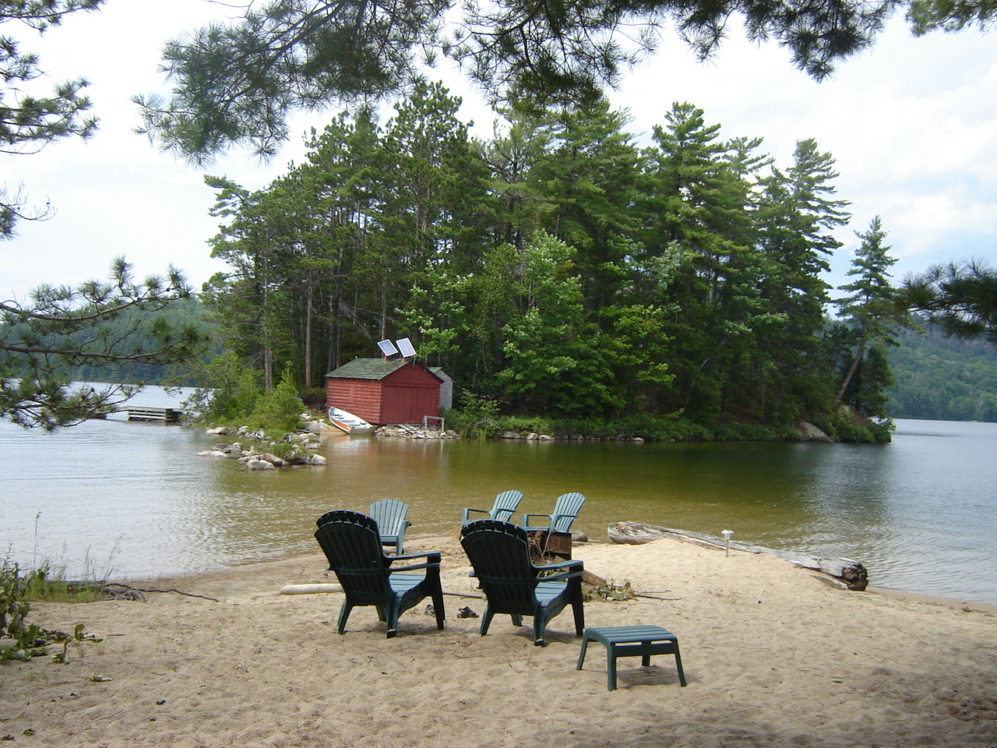

**PRICE LIST**

Effective:

November 2021

November 2017

Managing Director:

**SOCAN** Society Of Composers, Authors and Musicians

 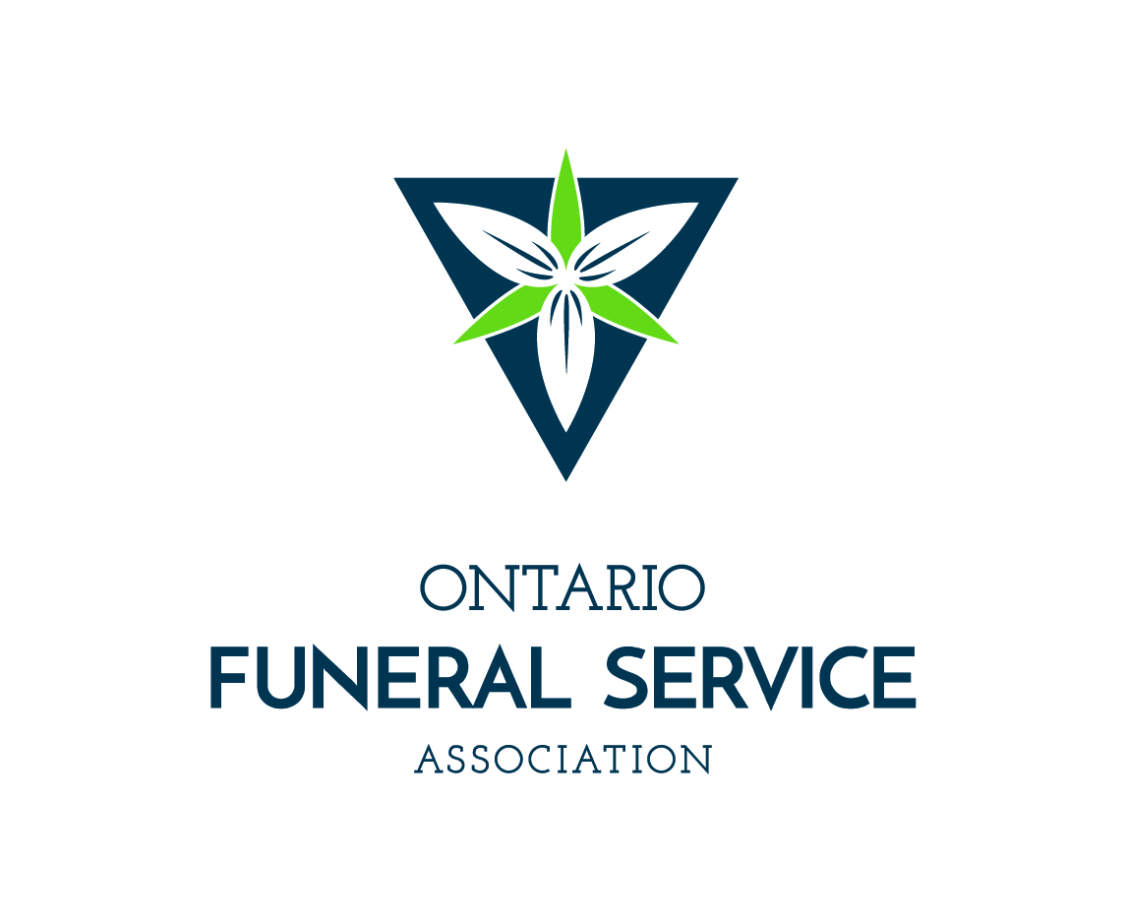

Josianne Régis

**Basic Professional Services and Co-Ordinating of Services**

* Basic professional fees:

Professional consultation with licensed personnel, which

may include but is not limited to, expert advice on

options to meet your needs. $350.00

* Co-ordination of all rites, activities and ceremonies $350.00

including essential services relating to disposition,

***drafting death notices, planning and***

***scheduling of services, funeral aftercare*** and direction

regarding possible government benefits.

**Documentation**

* This charge is for obtaining the necessary information

to complete the documentation legally required in

connection with the disposition of the deceased,

arranging for the filing of the documentation,

registration of the death, and

providing 8 copies of the death certificate

* Completion of all provincial and federal documents such $250.00

as the CPP Death Benefit, Survivor’s Pension, SIN,

Ontario Health Card, Receiver General and mailing:

**Transport of Remains**

* Transportation of the remains from the place of death

to our premises using a transfer vehicle, for distances

not exceeding 30 km. Additional charge applies for each

transportation request

- Using an unmarked van $130.00

- Using a funeral coach or hearse $250.00

* **Transportation** of the remains from our premises to the

crematorium in **Thessalon** using the service vehicle $250.00

* *Additional staff service charge for removal from a*

*residence or other non-institutional setting (per hour)* $125.00

* Additional staff service charge for remains in excess

of 225 lbs (per hour) $125.00

* Additional charge for distance (per kilometre both ways) $1.25

*Unless otherwise indicated, an unmarked van will be used in the transportation of remains.*

**Basic preparation of remains** (requires facilities for

basic preparation and or shelter) $250.00

* The preparation of the body for placement into the

Casket or container.

**Embalming**

* Embalming is sanitation, restoration and temporary

preservation. It is not legally required,

but may be recommended to preserve the body

between the time of death and the visitation or

disposition of the deceased. $435.00

**Staff services for visitation**

* Staff to coordinate and oversee the visitation

at our premises for a period up to 4 hrs. $300.00

**Preparation of remains for identification purposes**

* Exterior disinfection of remains and does not include

embalming. May include the setting of features,

shrouding or dressing for identification purposes. $175.00

**Staff services for ceremony**

* Staff to coordinate and oversee the ceremony

or memorial from our premises or offsite location $300.00

**WEEKEND SERVICES – ADDITIONAL STAFFING for**

**STATUTORY HOLIDAYS AND WEEKENDS** $250.00

* If services take place from the chapel or offsite during

the weekend or statutory holidays, additional charges will apply.

***Facility Charges***

**Facilities for preparation/embalming/shelter**

* Facilities used to prepare, embalm and or shelter

the body; this charge applies whenever the body is

in our facility for any purpose. $150.00

**Facilities for visitation** (*requires Staff services for visitation*)

* Designated facilities used for visitation $500.00
* Additional day of visitation $200.00

**Facilities for the day of the ceremony**

* Designated facility for gathering of the family/public

for procession to the church or ceremony venue. $300.00

**Facilities for ceremony** (*requires Staff services for ceremony*)

* Designated facilities at our funeral home used for the

ceremony or memorial service with seating capacity of 55

$475.00

**Facilities for Identification**

* Any viewing that takes place prior to disposition, one time only.
* Is limited to executor or family representatives and not more

than 3 people. Anything beyond this is considered “visitation”

and will be charged accordingly for use of the building.

Maximum time limit: 15 minutes $150.00

**Reception Facilities** (limited number of seating)

* Use of facilities for a reception following the

ceremony or memorial service which includes

the set up of the facilities, the use of the facilities

and amenities. Maximum number of persons 12 $65.00 hr.

***Vehicles***

* Hearse / Funeral Coach $250.00
* Lead Vehicle for Pallbearers or Clergy van $175.00
* Administration vehicle (this charge applies

whenever we provide service(s) to you $ 75.00

Additional mileage – mileage travelled beyond 30 km

from our facility will be subjected to an additional charge

per km both ways. $1.25

* Additional vehicle and staff services for floral delivery $25.00

within a 10 km radius to a maximum of 20 floral

arrangements. Delivery time to be determined

at our discretion

**Casket Selection:** *caskets not suitable for cremation*

**Name & Manufacturer Description Price**

|  |  |  |
| --- | --- | --- |
| Combo Cremation Tray  #CR199-00007 Victoriaville | Adult Standard – 74” x 23” x 13”  No lining, plywood / cardboard combo | $125.00 |
| Basic Cremation Container  #5084 Victoriaville | Adult standard – 76” x 24” x 13”  No interior, Particle board base / Cardboard top | $225.00 |
| Oversize Basic Cremation Container #5081 Victoriaville | Adult oversize – 78” x 28” x 15”  No interior, Particle board base | $450.00 |
| Glenwood  #80-5085-00 Victoriaville | Adult standard, 80 5/8 ”L X 25 1/8”W X 13 3/8”H, Basic Beige Crepe Interior, Natural Finish, Solid Select Wood Construction | $495.00 |
| Stillborn 90-18W-90 Victoriaville | Infant 18: white 20 1/8 X 9 ½ X 7 ½  Polyester white interior, exterior veneer construction | No Charge |
| K Panel #90-42W-30  Victoriaville | Infant, 42” White, 44 1/8”L X 18 ½”W X 13 ½”H  White Rayon Interior, Embossed King White Finish, Veneer Construction | $200.00 |
| Full Couch  #90-36W-60 Victoriaville | Infant, 36” White, 38 1/8”L X 16 ¼”W X 12”H, White Rayon Interior, Embossed King White Finish, Veneer Construction | $370.00 |
| Hampton #901-02  Victoriaville | Adult standard, 78 ½”L X 24 ¾” W X 14 ½”H,  Lift Plate Lid, White Silk Interior, Grey Plain Fabric Finish, Particle Board Construction | $995.00 |
| Toledo Oversize #90-55-03  Victoriaville | Adult oversize, 80 ¼”L X 31 ¾”W X 17 ¾”H, White Silk Interior, Blue Plain Fabric Finish, Particle Board Construction | $1,395.00 |
| Puma # 52652  Victoriaville | Adult standard, 81 1/8”L X 29 ¼”W X 19 7/8”H,  Beige Crepe Interior, Satin Finish, Poplar and Veneer Construction | $1,895.00 |
| Austin #523402  Victoriaville | Adult standard, 80 ½”L X 27”W X 18 ¾”H, Eggshell Crepe Interior Satin Finish  Bumper Handles Poplar and Poplar veneer | $2,445.00 |
| Winfield #5430  Victoriaville | Adult standard, 82 ¾”L X 28 ½”W X 22 ¾”H, Tan Crepe Interior, Satin Finish, Veneer Poplar Construction | $2,450.00 |
| Titan #682 Victoriaville | Adult standard, 83”L X 27 ½”W X 20 ¾”H, Beige Crepe Interior, Gloss Finish, Veneer Poplar Construction | $2,595.00 |
| Digby #62  Victoriaville | Adult standard, 83”L X 27 ½”W X 20 ¾”H, Tan Crepe Interior, Saffron Gloss Finish, Veneer Ash Construction | $2,795.00 |
| Borealis #.359  Victoriaville | Adult standard, 81”L X 27”W X 20”H  Beige Crepe Interior, Satin,finish, Solid Ash & Veneer Components | $2,850.00 |
| Libro #5430  Victoriaville | Adult standard 83”L x 27.5”L x 20 ¾” H Beige  Crepe Interior, Satin finish, Poplar/Veneer construction | $2,895.00 |
| Hartvic # 5410  Victoriaville | Adult Standard 83” x 27 ½ “ x 20 ¾ “  Dark Almond and Satin Finish  Tan Crepe Interior Interchangeable Corners | $3,325.00 |
| Camo #303  Northern Casket | Adult standard, 84”L X 32”W X 23 7/8”H, Rosetan Crepe interior, adjustable bed  Ash veneer sides and top, realtree camo | $3,470.00 |
| Dominion #5610  Victoriaville | Adult standard, 82 ¾”L X 28 ½”W X 22 ¾”H, Tan Crepe Interior, Titian Gloss Finish, 3” Thick Solid Plank Silver Maple | $3,675.00 |
| Atlantic Blue #1768 **\***  Victoriaville | Adult standard, 84”L X 29”W X 24”H, Light Blue Crepe Interior, Acylic Shaded Lustrous Finish, 18ga Accoseal Steel | $3,750.00 |
| Meredith #505460  Victoriaville | Adult standard, 82”L X 27/2”W X 23”H, Pearl Eyelet Interior, High Gloss Finish, Poplar Veneer with Engineered Wood Construction and Hardwood Solids | $3,850.00 |
| Forest #1852 **\***  Victoriaville | Adult standard, 83 ¾” L X 29 ½”W X 23 3/4”H, Rose Bellaire Tan Crepe, Brown Edge Copper Finish , 18 ga Accoseal Steell | $4,125.00 |
| Simcoe #5740  Victoriaville | Adult standard, 82 ¾”L X 28 ½”W X 22 ¾”H, Tan Crepe Interior, High Gloss Finish, 3” Thick Solid Plank Red Oak, includes Interchangeable Corners | $4,150.00 |
| Hamilton #5050 **\***  Victoriaville | Adult standard, 83”L X 28”W X 24 ¾”H, Pink Crepe Interior, Winter Bloom Finish,  18ga Accoseal Steel | $4,250.00 |
| Maxima #5710  Victoriaville | Adult standard, 82 ¾”L X 28 ½”W X 22 ¾”H, Tan Crepe Interior, Satin Finish, 3” Thick Solid Plank Red Oak, includes Interchangeable Corners | $4,295.00 |
| Woodstock #5750  Victoriaville | Adult standard, 82 ¾”L X 28 ½”W X 22 ¾”H, Beige Velvet Interior, Topaz Satin Finish, 3”  Thick Solid Plank Red Oak, Interchangeable  Corners | $4,425.00 |
| ***RENTAL:*** Dominion #5610  Victoriaville | 82 5/8”L X 30”W X 23 ¼”H, Tan Crepe Interior, Titian Gloss Finish, 3” Thick Solid Plank Silver Maple, All Wood Construction Insert with Cardboard Lid | $2,200.00 |
| Metal Sealer #97-FJF-003 **\***  Victoriaville | Adult standard, No interior lining,  Copper appearance finish, metal | $995.00 |

URN SELECTION:

**Name & Manufacturer Description Price**

|  |  |  |
| --- | --- | --- |
| Aqua Enamelled  Keepsake #KS-1494  Gravure Craft | 2”W X 2”D X 2 ¾”H  Aluminum, Aqua & Silver | $80.00 |
| Carthage Keepsake  #KS-19070 Gravure Craft | 2”W X2” D X 3”H  Brass, Brown & Gold | $80.00 |
| Florentine Keepsake  #KS-2005 Gravure Craft | 2 1/8”W X 2 1/8”D X 3 ¼”H  Etched Brass, Black & Gold | $80.00 |
| Butterfly Cloisonné Heart  Keepsake #833H Eckles | 2 ¾”W X 1 ¼”D X 2 ½” H  Brass, Black & Assorted Colors | $80.00 |
| Reflections of the Soul  Keepsake #T712  Commemorate | 4 1/8” Diameter X 6 ¾” H  Silver appearance keepsake with candle insert | $140.00 |
| CAMO Urn  #NU-212 North Urn | 9 ½” W X 5 ¾” D X 9 ½” H  Ash wood with camouflage fabric | $375.00 |
| Praying Hands Keepsake  #UK899-30121 | 4.25” W x 2.75” D x 6.25” H  Marbleized Veneer | $175.00 |
| Serenity Angel Keepsake  #UK899-20022 Victoriaville | 2 ¾” Diameter X 10 ½ “ H  Cold Cast Metal, Pewter | $175.00 |
| Cloisonne Keepsake  #205410 Batesville | 2” Diameter X 3.44” H  Copper Black Onyx | $135.00 |
| Rose Keepsake  #UK43020014 Victoriaville . | 13 5/8” Long  Aluminum - Pewter | $165.00 |
| Serenity Angel Keepsake  #UK335-20002 Victoriaville | 2 ¾” Diameter X 10 ½ “ H  Cultured Granite | $175.00 |
| Cast Stone #940114  Dodge | 10.5”W x 6.5”H x 7.5” D  Composite | $395.00 |
| Rosewood #US899-30034 Victoriaville | 9.5 “ W X 6.5 “D X 4.75” H  Carved Wood | $295.00 |
| Thamesford #UR-2009PEW2  Gravure-Craft | 6 ¼”W X 6 ¼”D X 8 ½”H  Antique Enameled, Pewter | $195.00 |
| Nicodeme Victoriaville #US810- (00479,00480,00481,00482) | 6 7/8 “W X 5 ½”D X 9 ½”H Plastic,  Available in Dark Grey, Blue, Plum or Green | $195.00 |
| Heritage  #US410-00436 Victoriaville | 4 ½ “ W x 7” D x 8 “ H  Cast Zinc Choice of appliqué | $475.00 |
| Plastic Photo #UR2050  Gravure Craft | 6 ½” W X 6 ½” D X 10 ¾” H  Plastic, Black | $195.00 |
| Circle of Life # NU-211  North Urn | 6 ½”W X 6 ½”D X 10 ¾”H  Solid Cherry, Satin Finish | $395.00 |
| ROOTS ECO TREE URN  Victoriaville # US899-00015 | 8 ½” W X 8 ½” D X 13 ½” H  Biodegradable planting pot system including peat pellets, 3 types of seeds and fertilizer | $475.00 |
| Bristol #972353  Dodge | 7.13”W X 8.13”D X 8”H  Hardwood, Rosewood | $250.00 |
| Franklin #972350  Dodge | 7.75”W X 12.25”D X7.5” H  Hardwood, Rosewood | $250.00 |
| LoveTeak # LT101  NorthUrn | 8.5” Diameter x 10.5” H  Marble / Teak - Round | $545.00 |
| Spun Steel #UR2006  Gravure Craft | 6” W X 6” D x 9” H  Polished silver | $295.00 |
| Mexican Handcrafted  Basteris #10-02 | 12” W X 8” D X 5 ¾” H  Mexican Pine Wood, Hand painted | $295.00 |
| Brougham UR-2021  Gravure Craft | 9 ¾ “ W X 7 ¾ “ D X 10 “ H  Light Oak | $395.00 |
| Chestnut Bronze #205404  Batesville | 6.88” Diameter X 9.75” H  Handcrafted brass with polished accents | $450.00 |
| Ashen Pewter # 205396  Batesville | 6.88” Diameter X 9.75” H  Handcrafted brass with polished accents | $450.00 |
| Praying Hands # 001  Canadian Funeral Supply | 7 ¾”W X 7 ¾”D X 8 3/8”H  Solid Mahogany | $395.00 |
| Florentine #UR-2005  Gravure-Craft | 6 ¼”W X 6 ¼”D X 10”H  Etched Brass, Black & Gold | $395.00 |
| Antique Pewter #2812  Victoriaville | 5.5”W X 5.5”D X 10.75”H  Metal, Antique Pewter | $395.00 |
| Indigo Argent #606  Dodge | 7.5” Diameter X 10” H  Metal Alloy Indigo (Blue) | $450.00 |
| Fisherman #UR-3000  Gravure-Craft | 10 ¾”W X 7 ½”D X 8 ¾”H  Solid Oak, 3D Laser Engraved | $495.00 |
| Sheet Bronze Sand Vertical #235601  Batesville | 4.44”W X 8.19”D X9.06”H  Sheet Bronze, Sand  (with LifeSymbol or LifeStories Medallion) | $495.00 |
| Sheet Bronze Pewter  Horizontal #235557  Batesville | 8.94’W X 6.69”D X 6.06”H  Sheet Bronze, Pewter  (with LifeSymbol or LifeStories Medallion) | $495.00 |
| Fairmont #3523  Eckles | 11 5/8”W X 7”D X 6 ¼”H  Solid Cherry, Satin Finish Engraving | $545.00  + 95.00 |
| Muskoka #901MUSK  Eckles | 6 3/8”W X 6 3/8” D X 9”H  Black Etched Marble, Stone Engraving | $640.00  + 95.00 |
| Victoriaville US235-20010  Cherry Floral  **RENTAL URNS** | 5”W X 6” D X 7” H  Sheet Bronze Brass | $325.00 |
| Makore #91-Makore-00  Victoriaville | 10 5/8”W X 5 7/16”D X 7 5/8”H  Makore with Curly Maple, Diamond inlay | $55.00 |
| Solitude#800-128  Victoriaville | 10 ¼”W X 8 ¼”D X 6 ½”H  Hardwood over black carbon fiber fabric, High gloss | $55.00 |
| Basteris #10-01  Mexican Handcrafted | 10 ¼”W X 7 1/8”D X 6 ¾” H  Mexican Pine Wood, Hand painted | $55.00 |

**ENGRAVING IS AVAILABLE ON MOST URNS AT AN ADDITIONAL COST OF $95.00. Please inquire about availability and timeline**

**VAULT SELECTION**

|  |  |  |
| --- | --- | --- |
| **Name & Manufacturer** | **Description** | **Price** |
| Urn Vault #011  Eckles | 16”W X 16”D X 14”H  Fiberglass, Bristol White,  Inside Dimensions 12” X 12” | $345.00 |
| Casket Concrete Vault  #002  Manitoulin Vault  & Precast Concrete | Adult Oversize, 90”L X 34”W X 34”H,  No Interior Lining, Solid Concrete | $1,400.00 |
| Casket Metal Vault  #98-FJF-00 | Adult Standard, 89”L X 34”W X 34”H,  No Interior Lining, Copper Finish, 14ga. Steel | $1,895.00 |

**Tribute Supplies**

Register Book (standard) $30.00

Register Book (large, themed) $50.00

Acknowledgement Cards (25) $15.00

**Memorial Cards (printed onsite)**

* Set up fee (generic cards) $15.00
* Set up fee (custom cards) $30.00
* Prayer card (8 per sheet) $ 1.00ea
* Bookmarks (4 per sheet) $ 1.25ea
* 2 up (folding – 2 per sheet) $ 1.00ea

**Crucifix** $20.00

**Memorial Candle**

* Premier candle $30.00
* Square candle $40.00

LifeSymbols Keepsake Plaque (including 1 LifeSymbol) $75.00

LifeSymbols (if purchased separately) $25.00

Display stand for keepsake urns $15.00

**Equipment for visitation at a remote location**

* Deliver, set up and use of equipment necessary

for visitation or ceremony at a location other

than the funeral establishment $275.00

**Additional Staff services for visitation**

* Staff to coordinate and oversee the visitation

(Informal gathering) for a period which exceeds

the basic period selected. (Rated on an hourly basis) $ 45.00

**Removal of pacemaker or implant**

* The removal of a pacemaker or implant will be

carried out by a licensed professional. $ 75.00

**Keepsake Jewellery – Filling Fee**

* Filling of jewellery $25.00

**Death Certificates:**

* Additional copies per certificate $ 4.00

**Professional restorative procedures**

* In some circumstances, additional restorative

efforts beyond those captured in the standard

embalming procedure are necessary to enhance the

appearance of the deceased. Professional restorative

procedures will be charged per hour. $75.00

**Scattering of cremated remains**

* We will scatter cremated remains in accordance

with Ontario and municipal laws and by-laws on land.

Fees for scattering from a plane or boat will be in

addition to this charge and will be discussed upon

request. (Within a 30 km radius) $ 75.00

**Hairdressing**

* Should the family request the services of a

professional hairdresser then the rate will be determined

**Environmental Service Surcharge**

* A charge for biohazard materials and disposal costs

will be made in some circumstances; our professional

staff will discuss this issue with you to be determined

**Ship Out Services Charge**

* If remains are being shipped to another location,

we will arrange for transport and all necessary

paperwork. to be determined

**Refundable Deposit for Cremated Remains**

* When human remains are to be cremated, a

refundable deposit will be required to be paid.

If the cremated remains are not claimed within one

year of the cremation, the deposit may be used to

inter the cremated remains in common ground. If

the cremated remains are claimed before they are

interred, the deposit will be refunded. $350.00

***Disbursements***

Disbursements are items requested by the executor or next of kin and arranged by us. ***You are expected to pay for these items at the time the contract is entered into.*** The following are some items that are often identified as disbursements.

***Coroner’s fee*** – this is a fee charged by the coroner for issuing a certificate that allows cremation to take place. The fee is set by the Chief Coroner for Ontario.

***Clergy honorarium*** – this is an amount paid to the officiating clergy for their services. In some cases the amount is set by the clergy, in others it is an amount to be determined by you.

***Newspaper or radio notices*** – charges for death notices placed in the newspapers or radio or other media outlets.

***Municipal death registration fee*** – fee charged by the local municipality to register the death. The fee is set by the municipality and may vary.

***Luncheon*** – a fee charged by the organization responsible to prepare the funeral luncheon as requested by the family. The fee is set by the organization.

***Payment***

* Unless otherwise specified, payment is due within 30 days of signing the contract.
* Payment may be made by cash, cheque, money order, bank draft or **E-Transfer (email is:** [**elfuneralchapel@persona.ca**](mailto:elfuneralchapel@persona.ca)**) .**
* Beyond the allotted time, interest will be charged at a rate of 1.75% per month, which is equivalent to 21% per year (APR).
* If you are pre paying for services or supplies, pre-authorized chequing is also available.

***Funding***

* For your convenience, we offer prepayment of services. Monies received are held for you “in trust”, either at a bank, trust company or with an independent trustee. It will earn income over the years until it is needed to pay for the services you have requested.
* For further information, please see the Guide to Death Care in Ontario supplied by the BAO (Bereavement Authority of Ontario)
* thebao.ca/for-consumers/consumer-information-guide/

**Payment, Funding & Financing**

Additional information about the Funding, Payment and Financing options is available on request.

Ontario’s Funeral, Burial and Cremation Services Act 2002, regulates funerals, burials, cremations and related services. To learn more visit:

Ministry of Consumer Services at [www.ontario.ca/consumerservices](http://www.ontario.ca/consumerservices) or the

Bereavement Authority of Ontario: [www.bao/consumerinformationguide](http://www.bao/consumerinformationguide)

Established in Elliot Lake in *1979* and with a combined experience of over 75 years, our **Class 1 - Funeral Directors** understand the many challenges that accompany the important passages of life as well as the many obstacles that confront you during a difficult time.

As members of the **Ontario Funeral Service Association** as well as **Guaranteed Funeral Deposits of Canada** and **SOCAN** (The Society of Composers, Authors and Music Publishers of Canada) we have the best resources and advantages to allow you to make an informed decision.

The ***Elliot Lake Funeral Chapel & Cremation Centre Limited*** can provide you free placement of the notice on our website ([www.elliotlakefuneralchapel.com](http://www.elliotlakefuneralchapel.com)) , personalized memorial tributes and services from our chapel. We also assist you with the completion of the Canada Pension Plan Death Benefit as well as the Survivor’s Application, Old Age Pension, cancellation of the Ontario Health Card, Ontario Driver’s Licence, cancellation of the Social Insurance Number, notification to Receiver General and certification of valuable documents.

NOTES: